#!/usr/bin/env bash
echo "Current network namespace:"
readlink /proc/$$/ns/net
echo
echo "Container indicators:"
if [[ -f /.dockerenv ]]; then
echo "Docker container marker found"
else
echo "No /.dockerenv marker found (this does not prove the host is not containerized)"
fi
echo
echo "Namespace-aware process listing:"
ps -eo pid,comm | head -n 8
echo
echo "Optional Docker check:"
if command -v docker >/dev/null 2>&1; then docker --version; else echo "Docker CLI not installed"; fi
Out put

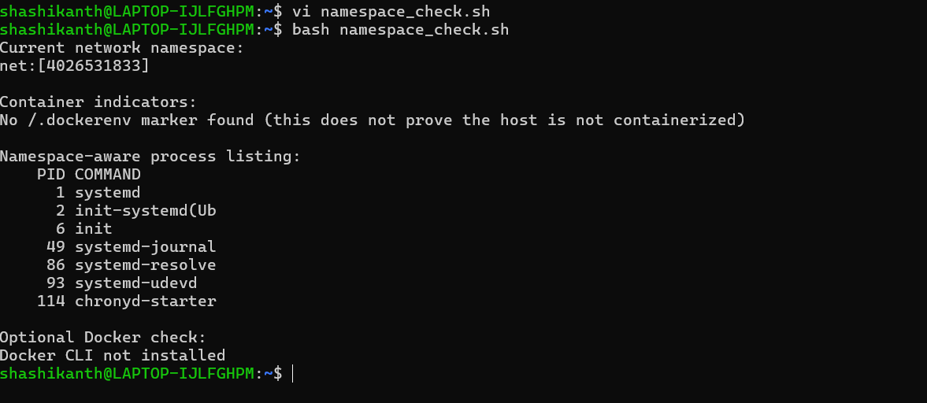s

